Hayley McKenzie

B00792771

EGM722 Project  
Open Spaces Analysis Code

How-To Guide

# Introduction

The aim of this project was to create a piece of code that was well-documented, readable, and reproducible.

The code created for this project looks to understand the types of open space within a given area and the number of people who have access to these open spaces. The topic of open spaces was chosen as the focus for this project as access to open spaces can have many health and wellbeing benefits for the population within the area.

There is a strong corelation with access to open spaces and higher levels of physical activity within the surrounding population, than to populations with limited access to open spaces (Coombes, Jones and Hillsdon, 2010). With the proportion of open space increasing inline with metal and physical health levels (Barton and Pretty, 2010).

It was for these reasons that open space availability was picked as this focus of analysis for the coding project.

The open space code can be used to map open spaces within a region using open-source data, it also carried out basic spatial analysis and calculations to identify the number of people with access to these open spaces and calculate the distance from open spaces to major roads, as this will allow easy access to these sites.

# Setup and Installation

In this section of the report the installation requirement for the open space code is demonstrated. These steps need to be carried out to ensure the code runs successfully. The open space code was created using python 3 in Jupiter Notebook.

* 1. Installing

Before the open space code can be used several packages and dependencies must be installed on the computer to allow the script access to the libraries and environments it needs to run.

To install these libraries and environments the computer must have access to a package management system such as anaconda. Anaconda was the chosen package management system that was used in the creation of the open spaces script. The below steps show the process for installing anaconda and the required dependencies.

Anaconda can be installed on a range of operating systems by locating the correct version from this url - https://docs.anaconda.com/anaconda/install/ and following the steps within the downloader.

Once anaconda has been installed the programming environment has to be created. Anaconda allows the user to setup several programme environments which allows different decencies to be selected depending on the requirements of the program/script being run/created.

To create a new program environment that will run the open spaces script in anaconda select the import button on the environments tab and navigate to the environment.yml file which is part of the open space’s repository on git hub (link in section 2.2).

The yml file will then load all the required dependencies for the open space script into anaconda. The dependencies for the open space script are shown in figure 1 below.

When the dependencies are loaded into anaconda it will also load additional packages that the dependencies are reliant on, so there will appear to be many more than the 8 listed below that are loaded into anaconda.

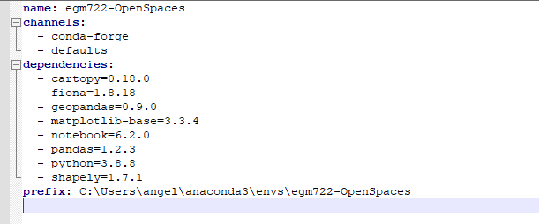

Figure 1: List of dependencies for Open Space Code

These packages are then loaded into the script at the start, as shown in figure 2 below, if there are any issues when importing these packages see section 5.1.

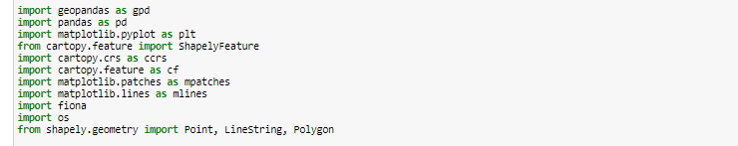

Figure 2:Python Libraries used in the code creation.

* 1. GitHub Repository

The open space code is hosted on GitHub and can be accessed using the following URL - <https://github.com/mckenzie-h/EMG722-OpenSpace>.

* 1. Downloading Datasets

During the creation process for the open space script several open-source datasets were downloaded for use in the analysis process, although this information is not provided as part of the repository the datasets can easily be downloaded from the locations show in table 1 below.

|  |  |  |  |
| --- | --- | --- | --- |
| Dataset Name | Script Name | Source | Source URL |
| Roads | NS_RoadLink | Ordnance Survey Open Data Portal | <https://osdatahub.os.uk/>  downloads/open/OpenRoads |
| Glasgow Boundary | GlasgowBoundary | Ordnance Survey Open Data Portal | [https://osdatahub.os.uk/](https://osdatahub.os.uk/downloads/open/BoundaryLine)  [downloads/open/BoundaryLine](https://osdatahub.os.uk/downloads/open/BoundaryLine) |
| Open Space | NS_GreenspaceSite | Ordnance Survey Open Data Portal | <https://osdatahub.os.uk/>  downloads/open/OpenGreenspace |
| Postcode Data | g_postcode_data | Scotland Census | https://www.scotlandscensus.gov.uk/ |

Table 1: Datasets downloaded for use within the script.

* 1. Data Preparation

After the data had been downloaded some minor preparation work was carried out.

* The roads link dataset was selected out of several datasets that were within the full roads download. The links were chosen as these represented the linear roads.
* The Glasgow boundary was selected from a shapefile of all of the parish region boundary data, this was done in ArcGIS when viewing the original download. The original parish region dataset covered the whole of the UK when first downloaded.
* The open spaces dataset was not processed before use but was checked in ArcGIS for format and data quality.
* The postcode data was originally downloaded as a csv from Scotland Census and was converted into a shapefile in ArcGIS when checking the data for quality.

.

# Methodology

In this section of the report the methodology used to produce the open space script will be highlighted.

* 1. Study Area

For this analysis, a study area of Glasgow City Council boundary was chosen. Glasgow City is Scotland largest town covering an area of 175.5km2 with a population of approximately 633,000 (Glasgow City Council, 2021). Glasgow city is an urban area which can mean that access to open spaces can be limited due to the number of buildings and demand for homes, office, and industry space within the area.

This can mean that the allocation of open space and the uses of the open space can be very important and require efficient and effective planning.

* 1. Analysis

When considering the type of analysis that could be undertaken when investigating open spaces, the most relevant type of analysis was spatial analysis. Spatial analysis is the process of visually and spatially mapping data which can then be interrogated to allow for decision making (Marušić, 2010). Once data has been spatially mapped it allows for analysis to be carried out which in turn can help councils or regions meet their open space requirements (Yeh and Chow, 1996), council are usually only given an area requirement for open spaces, but more factors should be consider such as availability of open spaces throughout the area. By mapping open space in the region more information about the distribution of open spaces can be determined (Durga Rao, 2005).

This analysis carried out in the open spaces script uses simple distance indicators (La Rosa, 2014) to calculate the population which has access to different types of open space.

# Results

In this section of the report the expected results of the open space script will be shown and discussed.

* 1. Open Space Mapping

In the first several sections of the script many steps are carried out to gain an understanding of the open-source datasets that have been downloaded from the ordnance survey.

The datasets are checked for the crs projections and the table displayed to show the attributes within each dataset.

The road and open space data set both covered a larger area than the required survey area, so each dataset is clipped to the Glasgow city council boundary as only the data within this boundary is required for the analysis.

Once the datasets have been processed, they are displayed on a map as shown in figure 3 below.

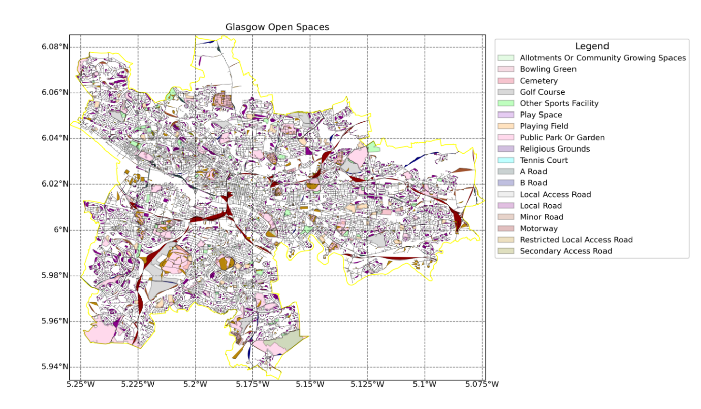

Figure 3: Open Space and Road data within the Glasgow City Council Boundary

The map is displayed with a legend and printed to a png file to allow for interrogation and understanding of the map figure. The map shows that the availability of openspace within Glasgow City council is varied and spread somewhat evenly throughout the city.

* 1. Data Analysis

Once the map has been created further analysis is carried out to be able to understand the dataset in more details.

For the open space dataset, a groupby and count function is used to gather more information about the types of open space within the Glasgow city boundary, figure 4 below shows the types and number of each type of open space within the Glasgow city boundary.

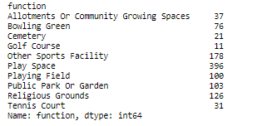

Figure 4: Type and count of each type of open space within the Glasgow City Council Area

By referring to figure 4 it can be seen that the most numerous type of open space within Glasgow City council is Play Spaces. This information could be useful to a council as it would allow then to keep track of the open space types available within the council region.

Following from the type identification the open space script goes on to carry out further analysis of the types of open space by creating a new column on the open space table which shows the area of each open space in km2, as shown in the sample table in table 2 below.

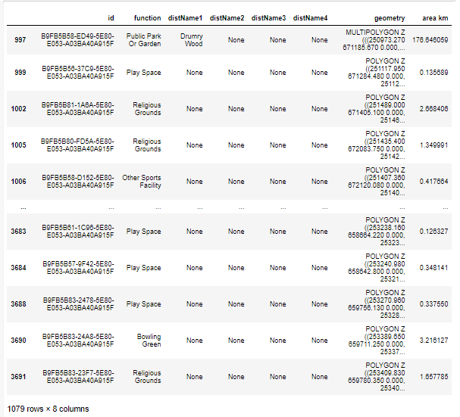

Table 2: Table showing addition of area km2 in open space dataset table.

This is further processed in the script to get a total area for three types of open space as shown in figure 5 below.

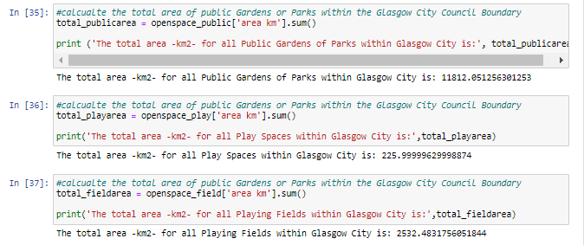

Figure 5: Area Calculations for 3 types of open space in Glasgow City Centre

The script then goes on to calculate the surrounding population for the chosen three types of open space. This will help to identify the availability of the open space to the population of Glasgow City Council. Figure 6 below shows the result on the population calculations for each of the three chosen open space types.

Once the populations surrounding the open spaces has been analysed it can be seen that although a significant percentage of the Glasgow City council have easy access to open space for many other open spaces can be harder to access which may in turn affect their physical and mental health.

Figure 6: Sample of code which shows the population surrounding the three types of considered open space

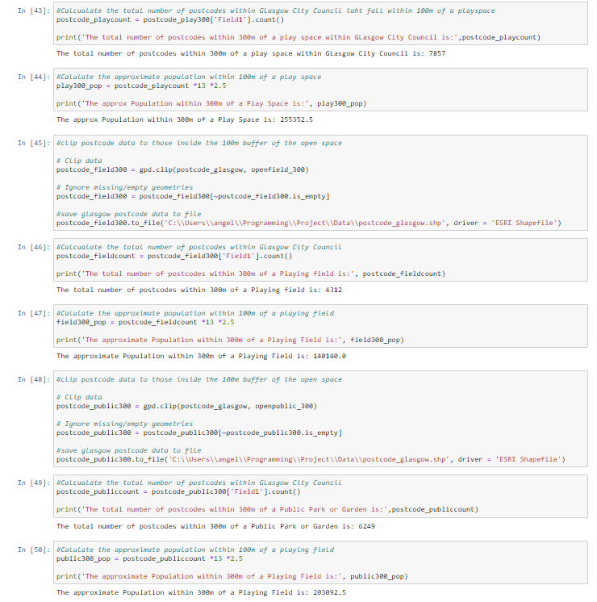

* 1. Future Work

At the time of submission for this script there was further analysis that could be carried out to continue to assess the access to open space with Glasgow City Council. Although some minor analysis was carried out on the road network within Glasgow city council Identifying the type of roads within the boundary and the length of the road sections. Further analysis could be carried out to identify the closest access road to each open space and highlight the type of the closest access road. This would help to quantify the accessibility of the open spaces.

# Troubleshooting

* 1. Module Import Error

If an error is appearing when trying to import packages such as geopandas, as shown in figure 3 below, this usually means either i) the dependency has not been installed correctly through the package management system or ii) the correct environment has not been selected within the package management system.

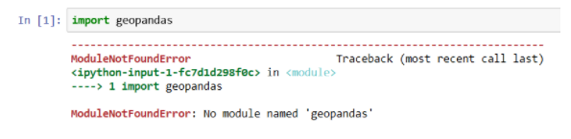

Figure 7: Import error when loading modules.

To test if the dependency has been installed within the working environment use the ‘conda list’ phrase within the anaconda prompt box or the coding programme, this will supply a list of all the dependencies within the environment.

If the resulting list of dependencies appears to have the required module but the error is still appearing, ensure the correct environment is selected within anaconda navigator.

* 1. General Troubleshooting

If there are any unexpected errors appear when running the open space script, there are several sites which can help with troubleshooting these include i) <https://stackoverflow.com/> and ii) <https://stackexchange.com/>.

Both of these sites contain a site or a series of sites where programmers from all levels can ask questions are receive advice on how to adapt and upgrade their coding scripts.

# References

* 1. References in Text

Barton, J. and Pretty, J., 2010. What is the Best Dose of Nature and Green Exercise for Improving Mental Health? A Multi-Study Analysis. *Environmental Science & Technology*, [online] 44(10), pp.3947-3955. Available at: <https://www.researchgate.net/publication/42587600_What_is_the_Best_Dose_of_Nature_and_Green_Exercise_for_Improving_Mental_Health_A_Multi-Study_Analysis> [Accessed 17 April 2021].

Coombes, E., Jones, A. and Hillsdon, M., 2010. The relationship of physical activity and overweight to objectively measured green space accessibility and use. *Social Science & Medicine*, [online] 70(6), pp.816-822. Available at: <https://www.sciencedirect.com/science/article/pii/S0277953609008156> [Accessed 27 April 2021].

Durga Rao, K., 2005. Multi-criteria spatial decision analysis for forecasting urban water requirements: a case study of Dehradun city, India. *Landscape and Urban Planning*, 71(2-4), pp.163-174.

Glasgow.gov.uk. 2021. *Briefing 1: Population in Glasgow (March 2021) - Glasgow City Council*. [online] Available at: <https://www.glasgow.gov.uk/index.aspx?articleid=26906> [Accessed 1 May 2021].

La Rosa, D., 2014. Accessibility to greenspaces: GIS based indicators for sustainable planning in a dense urban context. *Ecological Indicators*, 42, pp.122-134.

Marušić, B., 2010. Analysis of patterns of spatial occupancy in urban open space using behaviour maps and GIS. *URBAN DESIGN International*, 16(1), pp.36-50.

Yeh, A. and Chow, M., 1996. An integrated GIS and location-allocation approach to public facilities planning—An example of open space planning. *Computers, Environment and Urban Systems*, 20(4-5), pp.339-350.